Indoor Localization

Amanpreet Singh   
*Graduate Applied Computer Science*

Matin  
*Graduate* *Applied Computer Science*

*Abstract*—This project aims to compare the performance of three localization techniques: Trilateration/Multilateration, Centroid algorithm, and Grid-based RSS, for indoor node localization in wireless networking applications using Received Signal Strength Indication (RSSI) data. Three experiments were conducted, each utilizing an internally generated or real-world dataset with RSSI values for an unknown or tag node. The datasets were obtained from various sources and used in different scenarios to evaluate the performance of the three techniques. The results of the experiments were analyzed and compared using various metrics, such as mean error, standard deviation, and computation time. The findings suggest that the Trilateration technique outperformed the other techniques in terms of accuracy and precision in Bluetooth environments, while the Centroid technique demonstrated the highest robustness to noise and outliers. These results can assist researchers and practitioners in selecting the most suitable localization technique for their specific wireless networking application based on the specific requirements and constraints.

Keywords—Indoor localization, RSSI, Mutlilateration, Grid Based RSS, Wireless Sensor Network, performance evaluation.

# Introduction

Indoor localization has become a critical requirement in various applications, including healthcare, security, and retail. Accurate and reliable indoor localization can be achieved using various techniques, such as trilateration/multilateration, weighted centroid, and differential RSS. Received Signal Strength Indication (RSSI) data is commonly used in indoor localization to estimate the distance between devices and nodes in the network.

The aim of this project is to compare the performance of these three techniques in indoor localization, using RSSI data generated through internal calculations or obtained from two different real-world datasets. Both datasets are based on indoor localization and contain RSSI measurements from multiple nodes in an indoor room. The simulations of the three techniques are performed using the Python programming language. The motivation behind this project is the need for accurate and reliable indoor localization techniques for various applications. The specific objectives are to evaluate the accuracy, precision, and robustness of the three techniques, and to determine their suitability for indoor localization scenarios.

The project methodology involves conducting experiments, collecting data, analyzing results, and evaluating simulation outcomes. Its significance lies in the potential to enhance the field of indoor localization by offering insights into the performance of various techniques and identifying factors that impact accuracy and precision.

The project report follows a structured format, with the next section providing a literature review of indoor localization and localization techniques. The third section explains the project methodology, while the fourth section provides detailed information on each experiment or scenario. In the fifth section, the experimental results and analysis are presented, followed by a discussion of the findings and their implications in the sixth section. At the end, the study finishes with a summary of the findings and recommendations for further research.

# related work

Many articles give comparative analyses on indoor positioning technology.

Liu et al. [5] conducted one such study, which included a thorough examination of indoor location algorithms such as angulation, lateration, scene analysis and proximity. The research also looks at performance measures including accuracy, precision, complexity, robustness, scalability and cost, as well as technological options like GPS, RFID, WLAN, Bluetooth, UWB and cellular.

Xiao et al. [6] gave a complete overview of the state-of-the-art in wireless indoor localization methods from a device viewpoint, comparing device-based and device-free systems in terms of accuracy, cost, scalability, and energy efficiency.

Meanwhile, He and Chan [7] compared Wi-Fi fingerprinting technologies, focusing on two main areas: enhanced localization techniques and effective system deployment.

The study analyzed multiple approaches that used spatial and temporal signal patterns, taking indoor site availability, extra information for localization estimation, restrictions, and claimed mean accuracy into consideration.

Hassan et al. [8] conducted an indoor positioning study using visible LED light. Their research includes a comparison of different positioning systems such as Wi-Fi, Bluetooth Low Energy, and GSM, with criteria such as accuracy, robustness, complexity, cost, and infrastructure reusability considered. Latif et al [9] also evaluated the performance of multiple localization techniques.

Additionally, Gu et al. [12] compared indoor localization methods, with a focus on wireless personal networks.

Their extensive study examined a wide range of options, including both commercial and research-oriented solutions, based on factors such as security and privacy, cost, performance, resilience, complexity, user preferences, commercial availability and limits. Their findings were consistent with those of prior research [10], emphasizing that each solution employs a certain sort of technology, has its own design and performs best in specific situations.

In our work, we have evaluated the localization techniques on both real-world datasets and simulated datasets. Our methodology involved various scenarios, including boundary, inside, and random, across different technologies like Wi-Fi, Zigbee, and Bluetooth, and different levels of noise. Parameter tuning and optimization is done by changing the node locations, number of anchor nodes and performing various experiments on datasets. All the computations were conducted on a cloud-based GPU environment like Google Colab which refined calibration processes and provided bit more accurate results. These contributions provide insights into the effectiveness and limitations of the three techniques under different scenarios and helped us to identify an appropriate one for indoor localization.

# Objective and localization techniques

## Problem Statement

Indoor localization has become an increasingly important area of research due to the growing demand for location-based services in indoor environments. Unlike outdoor localization, indoor localization faces unique challenges such as signal attenuation, multipath fading, and shadowing caused by walls, ceilings, and other obstacles. These factors make it difficult to accurately estimate the location of a target in an indoor environment. The motivation for indoor localization is driven by the need for accurate location-based services in GPS-denied environments, such as underground parking lots, airports, hospitals, and shopping malls. In these environments, traditional GPS-based techniques fail due to weak or no GPS signals. Indoor localization can provide a solution to this problem by using wireless signals from Wi-Fi, Bluetooth, or Zigbee devices to estimate the location of a target. Therefore, the aim of this project is to explore and compare different indoor localization techniques and evaluate their performance under different scenarios. The findings of this project can be useful for developing efficient and accurate indoor localization systems for various applications.

## Localization Techniques

### Trilateration

Trilateration [3] is a model-based technique that uses distances to determine the receiver’s location numerically. To calculate with trilateration, we need three transmitting devices to obtain a 2-D position and four to find a 3-D position. The distances between the transmitter and the receivers, in addition to the right number of transmitting devices, are necessary. A frequent method for calculating the distance between devices is to use the RSSI of a signal. For 2-D space, with three anchor nodes N1, N2, N3 and positions in space be (a1, b1), (a2, b2), (a3, b3) respectively. We can find the unknown position (x, y) of the receiver as:

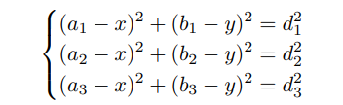

To minimize the positing error, we need to minimize

the following objective function using a non-linear least squares technique:

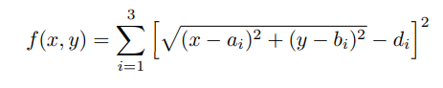

### Centroid Algorithm

The basic idea of a weighted centroid localization algorithm [2] based on RSSI is that unknown nodes gather RSSI information from the beacon nodes around them. Assuming there are anchor nodes in the WSN, with coordinates (x1, y1), (x2, y2), ..., (xn, yn), respectively, the location of the unknown node can be obtained by using the improved centroid algorithm estimating the coordinates of n nodes as:

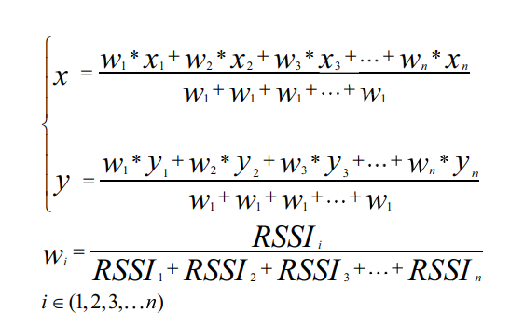

### Grid-based RSS

In this algorithm [1], the floorplan is considered and

divided into grid points of possible mobile locations. During the offline phase, theoretical received RSS values are calculated according to the representative (measured) RSS model for each point of the grid. During the online phase the measured RSS values are ’compared’ with the theoretical ones for each grid point. The grid point which has its theoretical RSS values closest (least squares) to the ones measured is determined as the estimated location (X,Y):

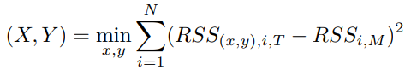

Here RSS (x, y), i, T denotes the theoretical RSS value at

position (x, y) from or at anchor i (see eq. 1), i =1. N with

N the number of anchors. RSSi, M is the measured RSS value from or at anchor i and is therefore required. RSS0 is obtained from a measurement at power Ptx.

# Methodology

In this section, we have presented three scenarios/test cases based on which we have performed our experiments. The results of the experiments are presented in the experiment and result section.

## Experiment 1 (5 tag nodes randomly)

The purpose of this first experiment is to provide the basic understanding of how the three localization techniques/algorithms localize the tag/unknown nodes or how the localization of tag/unknown nodes using three techniques looks like. In this experiment, we have 5 tag nodes distributed in 2d x-y coordinate plane and a total of 4 anchors nodes which are placed on all 4 corners. The Fig.1 shows the distribution of tag nodes and anchor nodes.

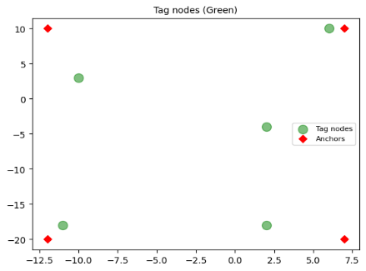

## 

Fig. 1. Tag (random) and anchor nodes.

These 4 anchors nodes measure the RSSI values for each tag node. For each tag node we have 4 RSSI values from 4 anchors. Then using these RSSI values we are estimating the location of tag nodes by leveraging localization techniques. The experiment and result section contains the results for the experiments.

## Experiment 2 (15 tag nodes across boundaries/center)

This experiment is based on simulated data we have generated in python. In this, we are placing the tag/unknown nodes starting from the center to the boundaries of the simulation workspace (x-y coordinate plane). Each tag/unknown node has its own identifying number. Here we are also using the 4 anchor nodes, one anchor node for each corner. The Fig.2 represents the x-y coordinate simulation workspace with tag nodes (green).

The 4 anchors are communicating with every tag node in the workspace and measured the RSSI values corresponding to tag nodes. So, for each tag node we have 4 measured RSSI values which we are using to locate a tag node. Results of localization from 3 different techniques (Multilatertion, Grid-based RSS and Centroid Algorithm) are shown in experiment and result section.

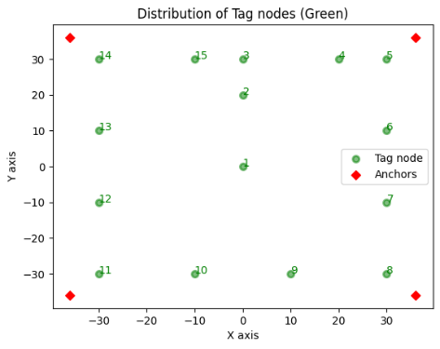

Fig. 2. Tag (boundary) and anchors nodes.

## Experiment 3

In this experiment, we are performing the localization based on real world dataset [4]. Unlike experiment 2 and 1, in which we have internally generated dataset (RSSI values), this experiment is using the RSSI values recorded from real-world settings using three different wireless technologies such as Wi-Fi, Bluetooth and Zigbee. The brief description of the real-world data set is as follows:

The Dataset (consist of 3 excel files corresponding to Wi-Fi, Bluetooth and Zigbee) is a comprehensive set of Received Signal Strength Indicator (RSSI) readings. The RSSI readings took place in a 6.0 x 5.5 m wide meeting room. The Fig.3 is the overview of the experimental topologies performed in the room.

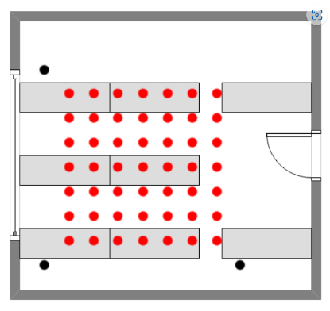

Fig. 3. Room layout with tags (red) and anchors (black).

Anchor nodes (black) were placed 4 m apart from one another in the shape of a triangle. RSSI reading (red) were taken with a 0.5 m spacing in the center between the anchor nodes. This created around 60 RSSI readings for each wireless technology (Wi-Fi, Bluetooth and Zigbee) that would comprise the database. In the figures, the black dots represent the location of the anchors and the red dots represent the locations where RSSI readings were gathered. The experiment and result section contains the 3 localization plots corresponding to Wi-Fi, Bluetooth and Zigbee for this scenario.

# Experiment and Results

In this section, we have presented the results of all the scenarios (experiment 1-3) mentioned in the methodology section. For each experiment, we have made many trails/iterations. All the experiments/simulations are performed on cloud based google colab GPU. We verified the performance of the localization techniques in terms of accuracy measured through the Mean Error and efficiency measured through the total time.

## Experiment 1

This experiment gives the basic understanding/view of how our localization of unknown/tag nodes using different techniques (Multilateration, Grid-based RSS and Centroid Algorithm) look like. As discussed in the scenario/experiment-1 of methodology/approach section, we have estimated the position of unknown/tag nodes using the RSSI values recorded by 4 anchor nodes. These RSSI values are calculated using internally generated dataset in python script. The scatter plot in Fig. 4 illustrates the distribution of tag/unknown nodes (black) in simulation workspace (xy coordinate plane). In this plot (Fig.4), we can easily visualize the results (estimated position of tag nodes) given by multilateration (red triangle), grid-based RSS (orange x) and centroid algorithm (green square).

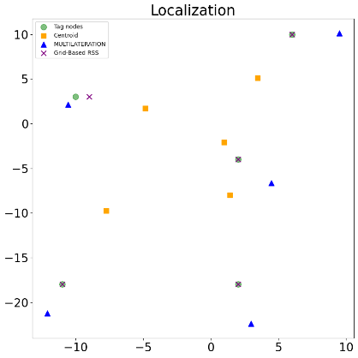

Fig. 4. Localization of 5 tag nodes.

As per the plot (Fig.4), grid-based RSS has more accurate estimation than centroid algorithm and multilateration. One thing to note is that when we ran this experiment on local system then grid-based RSS was not showing that much high accuracy (for 4 tag nodes out of 5) as shown in plot. When we run the experiment on Google Colab, grid-based RSS shows this much higher accuracy as shown in the plot.

## Experiment 2

As discussed in methodology/proposed approach section, we are generating the dataset internally in our python script for this experiment. We are calculating the value for RSS0 using *Friis* transmission equation. This equation calculates the power received by an antenna based on the transmitted power, distance, and antenna gains. For other parameters like frequency, path loss exponent (n), transmitted power and antenna gains, we are using the values which are commonly/widely accepted in many wireless communication systems for convenience and practical reasons. Below are the localization results for multilateration, grid-based RSS and centroid algorithm. The plots under this experiment 2 belongs to noise level 1.

### Multilateration

In the mentioned plot (Fig.5), the estimated positions (blue) have numerical values corresponding to actual node location (green). The node numbers help to identify estimated tag node location for an actual tag node location. As per the plot, we can see that for the majority of tag nodes, multilateration has given estimated location of tag nodes kind of close to actual location/position. The grey line joining the blue dots (estimated location) is just to make the plot understandable.

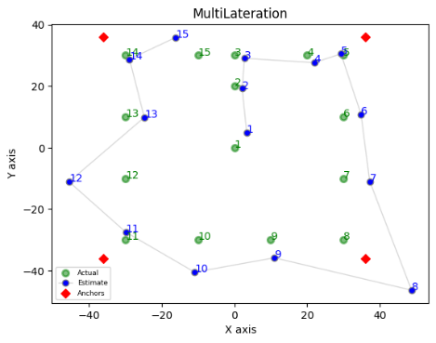

Fig. 5. Localization using multilateration.

### Grid-based RSS

As mentioned earlier, we have made many trials for each experiment. When we were executing our code of grid-based RSS on local system python (vs code) then the resulting output (estimated locations) was very poor. When we executed our same code on Google Colab, the output became improved. That is the reason we have performed all the experimentation on cloud-based Google Colab GPU which improved the calibration process. However, grid-based RSS is very unstable as it has high fluctuation rate in terms of accuracy/error. The Fig. 6 is the plot for the same.

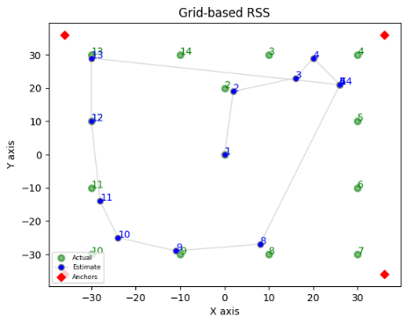

Fig. 6. Localization using Grid-based RSS.

We generated the above plot (Fig.6), which is kind of representable, for grid-based RSS after many trials on Google Colab. Otherwise, the plots were showing high error for estimated positions.

### Centroid Algorithm

Though the plot (Fig.6) has shown less accuracy than multilateration plot (Fig.5) and Grid based RSS plot (Fig.6) in terms of estimated position of tag nodes. On the other hand, the centroid algorithm is robust to noise/environment. It has less fluctuations in localization results. Whereas results from multilateration can be less accurate in some trials as compared to centroid algorithm. Hence the centroid algorithm is stable as per our results.

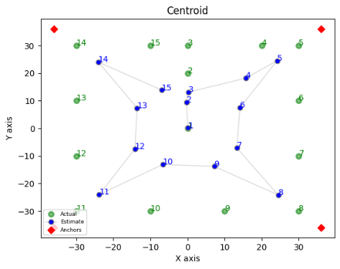

Fig. 7. Localization using centroid.

### Mean Error Vs Noise

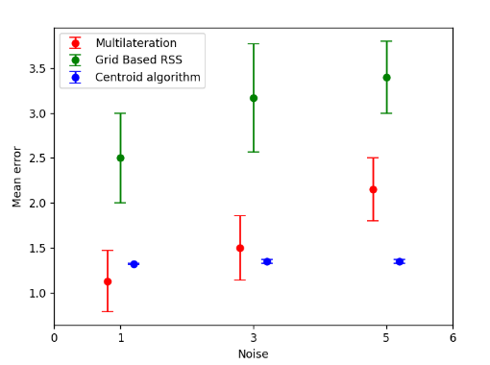

Fig. 8. Mean error Vs Noise.

The plot (Fig.8) represents mean error for localization techniques at different noise levels (1, 3, 5). At noise level 1, though multilateration has variance but it has the tendency to outperform the other 2 techniques. Also, the mean error of multilateration is less than centroid algorithm and grid-based RSS. At noise level 3, multilateration mean error became a bit more than centroid algorithm but in still some cases it gives higher accuracy than centroid algorithm. Whereas centroid algorithm’s mean error remains same as of noise level 1. At noise level 5, multilateration’s mean error becomes more than mean error at noise level 3. Where mean error of centroid algorithm remains unchanged even at noise level 5. So, we can conclude that mulilateration’s accuracy is impacted by noise/environment and centroid algorithm is robust to noise/geometry of environment. For grid-based RSS, its accuracy is impacted by noise. Also, it is very unstable and has high variance plus it gives fluctuating results for estimated locations.

## Experiment 3

As discussed in the scenario/experiment3 of methodology section, this experiment is based on publicly available real-world dataset. Three anchors were used to record the RSSI reading in a wide meeting room. The dataset has RSSI observations captured from three different wireless technologies (Wi-Fi, Bluetooth, and Zigbee). First, we discuss the result of localization from RSSI values captured by Wi-Fi technology, then we discuss results pertinent to Bluetooth and Zigbee. We have done the localization for all the tag nodes present in dataset in our python script but in the following plots we have shown the localization results of 3 randomly chosen tag nodes. The reason for choosing only 3 nodes out of all for the plots is to clearly represent the localization results of 3 techniques in visuals.

### Wi-Fi

The values of "RSS0" (received signal strength at a distance of 1 meter) and "pathloss exponent n" (rate at which signal strength decreases with distance) are specific to the Wi-Fi hardware and environment being used in the experiment. We have plotted the results of localization from 3 techniques (Multilateration, Grid based RSS, Centroid algorithm) in one plot. Through this plot we can easily figure out among the techniques which one is performing better. The presented plot (Fig.9) below illustrates these results.

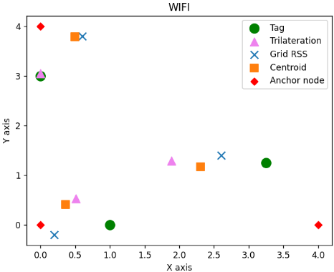

Fig. 9. Wi-Fi localization.

The points (green, pink, red, blue, and orange) in the Fig.9 plot are labeled as per the output of respective localization technique. In this plot, for the tag node (green) at coordinate (0,3), trilateration (pink) technique has estimated location very close to actual location of tag node. While the other 2 techniques (grid-based RSS, centroid algorithm) have kind of same estimated location for that tag node (0,3). For the tag node at coordinates (1,0), trilateration and centroid algorithm has estimated the location for the same close to the coordinates (0.5, 0.5). Whereas Grid-based RSS estimated nearby (0.2, -0.1). For the third tag node (3.3, 1.1), the estimated location from three techniques can be visualized in the plot.

### Bluetooth

To calculate the distance between the tag nodes and anchors, we have used values for “RSS0” (received signal strength at a distance of 1 meter) and “pathloss exponent n” (rate at which signal strength decreases with distance) which are specific to the “Bluetooth” hardware being used in the gathering RSSI readings. In this case also, we have plotted the result (estimated location/position) of localization techniques for the same tag nodes to show case the difference/effect of wireless technologies on localization accuracy/error. Below is the plot for the same (Fig.10).

In this case, we can see in the given plot that for all the 3 tag nodes, multilateration, centroid algorithm and grid-based RSS have estimated locations different from Wi-Fi plot. Especially for grid-based RSS, which has higher error of localization than the two others.

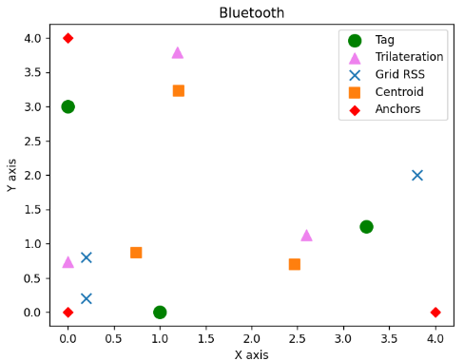

Fig. 10. Bluetooth localization.

### ZigBee

We can conclude from the plot that for the 3 tag nodes, Zigbee case has shown the highest error of localization as compared to other 2 (Wi-Fi and Bluetooth). Below is the plot showing the localization results (Fig.11).

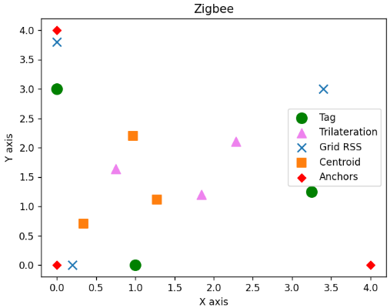

Fig. 11. Zigbee localization.

From the points, it is even difficult to figure out which estimation belongs to which corresponding tag node except Grid-based RSS. Though it also has estimation error but at least we can figure out the estimations of corresponding tag nodes.

### Mean Error (Wi-Fi, BLuetooth and Zigbee)

We have plotted the mean error of localization techniques (Trilateration, Grid-based RSS, and Centroid Algorithm) for each wireless technology (Wi-Fi, Bluetooth and Zigbee). As mentioned before, we have made several trials for each experiment and got the localization error as the Euclidean distance between the predicted position and the actual position of a tag node. So, mean error is the average error for all the tag nodes. Below is the plot (Fig.12) for the same.

For Wi-Fi, centroid algorithm has shown lowest mean error which is around 1.3. Whereas trilateration has bit more than centroid which near about 1.7. The difference between the centroid and trilateration mean error is max 0.5. So, we can say that their performance is kind of the same under Wi-Fi. Grid-based RSS has high fluctuations with respect to error and accuracy. We can say that it is very unstable and has high variance/standard deviation as compared to centroid and trilateration. For Bluetooth, the mean error for trilateration and centroid is very close to each other. While the mean error for grid-based RSS is still high and unstable/fluctuating. In the case of Zigbee, trilateration and centroid algorithm showing same kind of behavior as that of Wi-Fi and Grid-based RSS again has high mean error. So, overall, we can conclude that the centroid algorithm is robust to different technologies. Trilateration has minor variations. Whereas grid-based RSS has high fluctuations irrespective of communication technology.

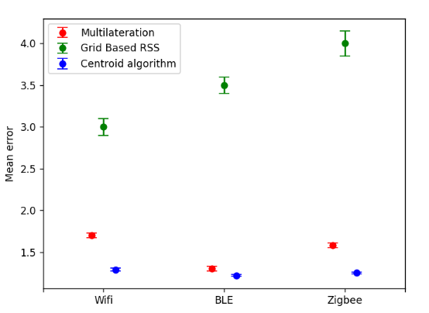

Fig. 12. Zigbee localization.

# Future works

To further improve the performance of the presented techniques, there are several potential directions for future work. One possible direction is to parallelize the algorithms to increase their efficiency. This can be achieved by distributing the computations across multiple processors or GPUs, which can significantly reduce the processing time for large datasets. Another area for improvement is the integration of correction methods such as Static offset and Linear regression. These techniques can help to reduce the effect of noise and improve the accuracy of the localization algorithms. Furthermore, it would be interesting to compare the performance of the presented techniques with localization using Ultra-Wideband (UWB) based radio technology. UWB is a promising technology for high-precision indoor localization and comparing it with the presented techniques can provide valuable insights into their relative strengths and weaknesses.

In summary, there are several promising avenues for future work, including parallelization, integration of correction methods, and comparison with UWB-based localization. These directions can help to further improve the accuracy and efficiency of indoor localization techniques.

# Conclusion

Based on the simulations and analysis conducted in this project, it can be concluded that the Centroid algorithm is the most efficient technique for indoor localization using wireless signals. This algorithm is found to be robust to noise levels and has less fluctuations in accuracy/error as the technology changes. On the other hand, Trilateration works best in Bluetooth environments, but its accuracy decreases as the noise level increases. The Grid-based RSS technique showed a high fluctuation rate in all cases and is not considered a stable method for indoor localization. ***Average time to localize a node taken by trilateration, grid RSS, and centroid is 0.000427s, 0.0169s, and 0.000287s respectively.*** This shows that centroid algorithm is more efficient than others. In terms of memory usage, trilateration occupies more memory than other techniques as observed on cloud GPU with 280 computing units while running dataset of 200k records. This limits its suitability for larger datasets. Furthermore, cloud-based GPU environment, such as Google Colab, refined the calibration process and improved the results especially for grid-based RSS than local systems. Overall, the Centroid algorithm is stable for indoor localization, especially in mixed-technology environments. However, the choice of technique should be based on the specific requirements of the application, such as noise levels, technology, and dataset size.

# References

1. Podevijn N, Plets D, Trogh J, Karaagac A, Haxhibcqiri J, Hoebeke J, Martens L, Suanet P, Joseph W. Performance comparison of rss algorithms for indoor localization in large open environments. In2018 International Conference on Indoor Positioning and Indoor Navigation (IPIN) 2018 Sep 24 (pp. 1-6). IEEE.
2. Wang ZM, Zheng Y. The study of the weighted centroid localization algorithm based on RSSI. In2014 International Conference on Wireless Communication and Sensor Network 2014 Dec 13 (pp. 276-279). IEEE.
3. Manolakis DE. Efficient solution and performance analysis of 3-D position estimation by trilateration. IEEE Transactions on Aerospace and Electronic systems. 1996 Oct;32(4):1239-48.
4. <https://github.com/pspachos/RSSI-Dataset-for-Indoor-Localization-Fingerprinting>
5. Liu, H.; Darabi, H.; Banerjee, P.; Liu, J. Survey of wireless indoor positioning techniques and systems. IEEE Trans. Syst. Man Cybern. C (Appl. Rev.) 2007, 37, 1067–1080.
6. Xiao, J.; Zhou, Z.; Yi, Y.; Ni, L.M. A survey on wireless indoor localization from the device perspective. ACM Comput. Surv. 2016, 49, 1–31
7. He, S.; Chan, S.H.G. Wi-Fi fingerprint-based indoor positioning: Recent advances and comparisons. IEEE Commun. Surv. Tutor. 2016, 18, 466–490.
8. Hassan, N.U.; Naeem, A.; Pasha, M.A.; Jadoon, T.; Yuen, C. Indoor positioning using visible LED lights: A survey. ACM Comput. Surv. 2015, 48, 1–32.
9. Latif E, Parasuraman R. Online indoor localization using doa of wireless signals. arXiv preprint arXiv:2201.05105. 2022 Jan 13.
10. Gu, Y.; Lo, A.; Niemegeers, I. A survey of indoor positioning systems for wireless personal networks. IEEE Commun. Surv. Tutor. 2009, 11, 13–32.
11. Van Haute T, Rossey J, Becue P, De Poorter E, Moerman I, Demeester P. A hybrid indoor localization solution using a generic architectural framework for sparse distributed wireless sensor networks. In: 2014 federated conference on computer science and information systems (FedCSIS), 2014. p. 1009–1015. IEEE